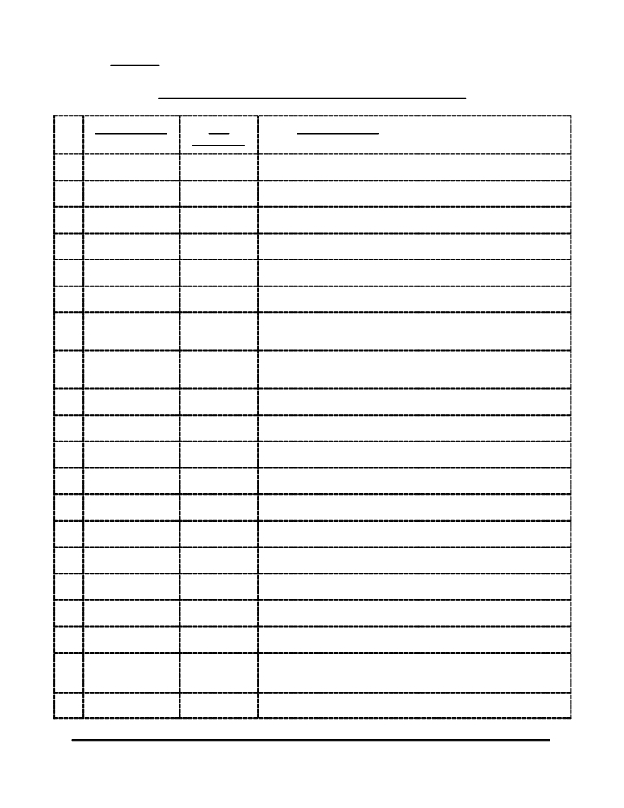

XIV. REVIEW

Messianic Prophecy Cited in the New Testament

N.T. Reference O.T. Gist of Prophecy
Reference

1. Matt. 1:23 Isaiah 7:14

2 Mic. 5:2

3 Hos. 11:1

4 Jer. 31:15

5 Isaiah 40:3

6 Isaiah 9: 1ff

7 Isaiah 53:4

8 Isaiah 35:5ff,
61:1

9 Mal. 3:1

10 Isaiah 42:1-4

11 John 1:17

12 Isaiah 6:9f.

13 Psa. 78:2

14 Isaiah 29:13

15 Zech. 9:9

16 Psa. 118:26f.

17 Matt. 21:16

18 Matt. 21:42

19 Matt. 23:39

20 Matt. 24:30

MESSIANIC PROPHECY Page -48- REVIEW
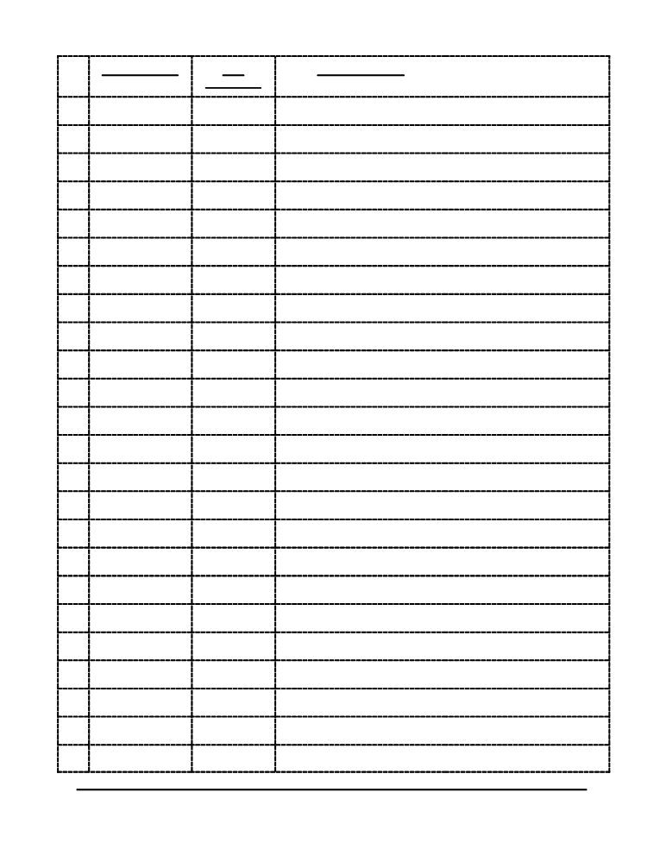

N.T. Reference O.T. Gist of Prophecy
Reference

21 Matt. 26:31

22 Matt. 26:64

23 Matt. 26:64

24 Matt. 27:9f.

25 Matt. 27:34

26 Matt. 27:43

27 Matt. 27:43

28 Matt. 27:46

29 Mark 1:2

30 Isaiah 40:3

31 Isaiah 6:9

32 Isaiah 29:13

33 Psa. 118:25

34 Psa. 118:22f

35 Psa. 110:1

36 .Dan. 7:13

37 Zech. 13:7

38 Dan. 7:13

39 Psa. 110:1

40 Mark 15:24

41 Mark 15:34

42 Luke 1:17

43 Luke 1:76

44 Luke 1:79

MESSIANIC PROPHECY Page -49- REVIEW
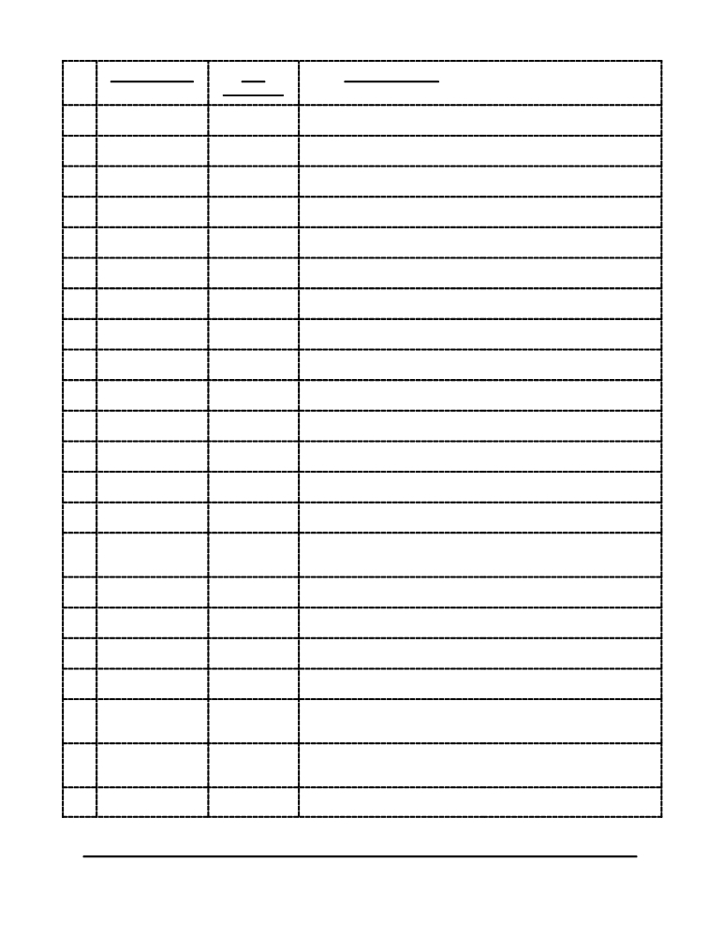

N.T. Reference O.T. Gist of Prophecy
Reference

45 Luke 2:32

46 Luke 3:4f.

47 Luke 4: 18f.

48 Luke 7:27

49 Luke 8:10

50 Luke 19:38

51 Luke 20:17

52 Psa. 110:1

53 Isaiah 53:12

54 Psa. 110:1

55 Psa. 22:18

56 Isaiah 40:3

57 Psa. 69:17

58 Isaiah 54:13

59 Psa. 89:4;
Mic. 5:2

60 Psa..118:25f.

61 Zech. 9:9

62 John 12:38

63 John 12:40

64 John 13:18 cf.
John. 17:12

65 John 15:25

66 John 19:24

MESSIANIC PROPHECY Page -50- REVIEW
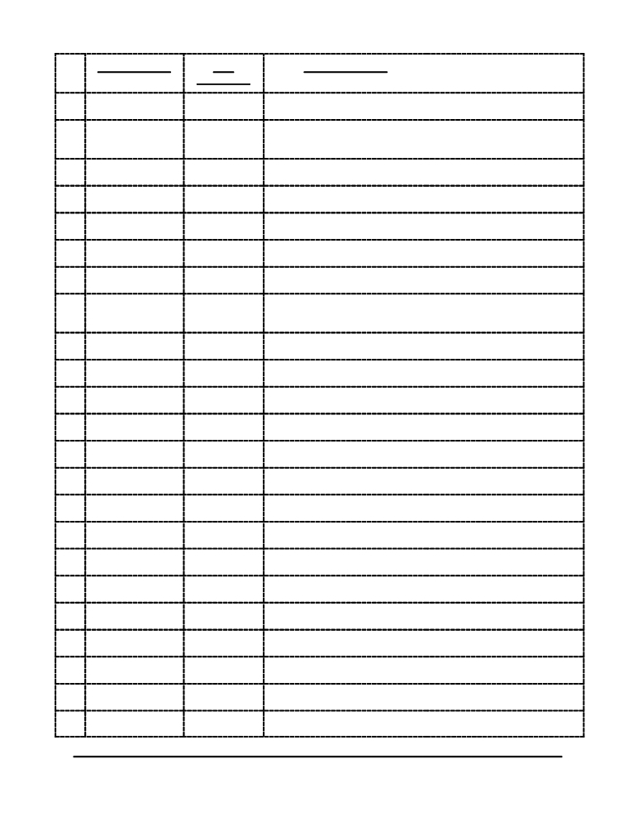

N.T. Reference O.T. Gist of Prophecy
Reference

67 John 19:28

68 John 19:36

69 John 10:37

70 Acts 1:20

71 Acts 2:16-21

72 Psa. 16:8-11

73 Psa. 110:1

74 Deut. 18:15,
19

75 Gen. 22:18

76 Psa. 118:22

77 Psa. 2:1

78 Deut. 18:15

79 Isaiah 53:7-9

80 Psa. 2:7

81 Acts 13:34

82 Acts 13:35

83 Acts 13:47

84 Acts 15:16-18

85 Rom. 9:25f.

86 Rom. 9:33, 10:11

87 Rom. 10:13

88 Rom. 11:8

89 Rom. 11:9f.

MESSIANIC PROPHECY Page -51- REVIEW

N.T. Reference O.T. Gist of Prophecy
Reference

90 Isaiah 59:20f.

91 Isaiah 27:9

92 Isaiah 45:23

93 Psa. 18:49

94 Deut. 32:43

95 Psa. 117:1

96 Isaiah 11:10

97 Isaiah 52:15

98 Psa. 8:7

99 Isaiah 25:8

100 Hos. 13:14

101 2 Cor. 6:2

102 2 Cor. 6:16

103 2 Cor. 6:18

104 Gal. 3:8, 16

105 Gal. 4:27

106 Eph. 2:17

107 Eph. 4:8

108 Eph. 5:14

109 Heb. 1:5

110 Heb. 1:5

111 Deut. 32:43

112 Psa. 45:6f.

113 Psa. 102:25-

MESSIANIC PROPHECY Page -52- REVIEW
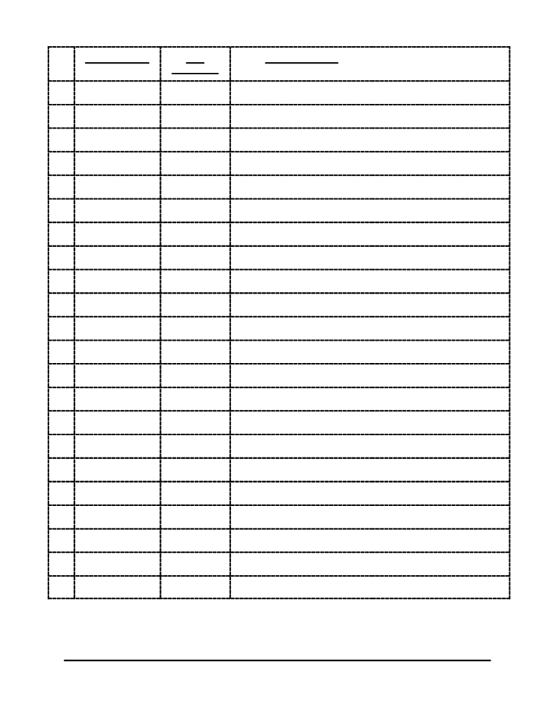

N.T. Reference O.T. Gist of Prophecy
Reference

27

114 Psa. 110:1

115 Psa. 8:4-6

116 Psa. 22:22

117 Isaiah 8:17f.

118 Psa. 2:7

119 Psa. 110:4

120 Psa. 110:4

121 Heb. 8:8-12

122 Heb. 10:5-9

123 Heb. 10:13

124 Heb. 10:16f.

125 Heb. 10:37f.

126 Heb. 12:26

127 1 Peter 2:6

128 1 Peter 2:7

129 1 Peter 2:8

130 1 Peter 2:10

131 1 Peter 2:22

MESSIANIC PROPHECY Page -53- REVIEW

SCRIPTURES REFERENCED

Old Testament

1 Chr. 15:19 (65, 140)
1 Chr. 16:5 (65, 140)
1 Chr. 17:13 (21, 140)
1 Chr. 25:1 (65, 140)
1 Chr. 5:1 (29, 140)
1 Chr. 6:31 (65, 140)
1 Kings 1:2 (34, 140)
1 Kings 1:32 (43, 140)
1 Kings 1:34 (43, 140)
1 Kings 13:2 (11, 140)
1 Kings 19:16 (7, 43, 140)
1 Kings 4:20 (26, 140)
1 Sam. 10:2 (39, 140)
1 Sam. 16:1 (43, 140)
1 Sam. 24:5 (43, 140)
1 Sam. 26:17 (67, 140)
1 Sam. 26:9 (43, 140)
1 Sam. 3:19 (7, 140)
1 Sam. 3:20 (43, 140)
2 Kings 16:1 (34, 140)
2 Kings 19:2 (9, 33, 140)
2 Kings 23:19 (11, 140)
2 Kings 24:17 (29, 140)
2 Kings 24:20 (29, 140)
2 Kings 25:1 (29, 30, 140)
2 Sam. 1:14 (43, 140)
2 Sam. 15:12 (75, 140)
2 Sam. 16:20 (75, 140)
2 Sam. 17:1 (75, 140)
2 Sam. 17:23 (75, 140)
2 Sam. 23:3 (47, 140)
2 Sam. 7:12 (7, 8, 23, 31, 108, 140) 2 Sam. 7:16 (31, 140)
2 Sam. 8:14 (27, 140)
Dan. 2:36 (37, 140)
Dan. 2:44 (14, 140)
Dan. 7:13 (128, 129, 140)
Dan. 7:3 (128, 140)
Dan. 8:17 (22, 140)
Dan. 9:24 (37, 140)

Dan. 9:25 (6, 7, 140)
Dan. 9:26 (37, 140)
Exod. 12:1 (116)
Exod. 12:13 (117)
Exod. 12:14 (120)
Exod. 12:24 (120)
Exod. 12:46 (100, 117, 140) Exod. 12:48 (120)
Exod. 12:5 (117)
Exod. 12:6 (117, 120)
Exod. 12:7 (117)
Exod. 13:1 (117)
Exod. 16:1 (118)
Exod. 16:15 (118)
Exod. 16:4 (118)
Exod. 20:19 (44, 115, 140) Exod. 21:32 (76, 140)
Exod. 28:41 (43, 140)
Exod. 29:2 (42, 140)
Exod. 29:21 (42, 140)
Exod. 29:36 (42, 140)
Exod. 30:11 (116)
Exod. 30:26 (42, 140)
Exod. 30:30 (43, 140)
Exod. 32:7 (44, 115, 140)
Exod. 34:27 (44, 115, 140)
Exod. 34:9 (44, 115, 140)
Exod. 4:22 (40, 140)
Exod. 40:9 (42, 140)
Ezek. 2:1 (22, 140)
Ezek. 21:25 (29, 140)
Ezek. 3:17 (6, 140)
Ezek. 34:23 (31, 140)
Ezek. 37:24 (31, 112, 140) Ezek. 37:27 (132, 140)
Ezek. 39:18 (93, 140)
Ezek. 8:11 (38, 140)
Ezra 1:1 (38, 140)
Ezra 9:3 (83, 140)
Gen. 1:1 (16, 140)
Gen. 12:1 (26, 140)

Gen. 12:3 (23, 133, 140)
Gen. 14:18 (45, 58, 115, 140) Gen. 2:15 (17, 140)
Gen. 2:16 (121, 140)
Gen. 22:17 (26, 140)
Gen. 22:18 (26, 131, 140)
Gen. 24:16 (34, 140)
Gen. 24:43 (34, 35, 140)
Gen. 26:4 (26, 140)
Gen. 28:13 (27, 140)
Gen. 28:14 (26, 140)
Gen. 28:18 (42, 140)
Gen. 3:14 (17, 140)
Gen. 3:15 (10, 12, 18, 19, 23, 25, 33,
57, 140)
Gen. 3:22 (124, 140)
Gen. 35:16 (40, 140)
Gen. 35:18 (39, 140)
Gen. 39:5 (116)
Gen. 49:10 (29, 140)
Gen. 50:20 (116)
Haggai 1:13 (6, 140)
Hosea 1:10 (20, 140)
Hosea 11:1 (40, 41, 140)
Hosea 3:5 (31, 140)
Isaiah 1:1 (9)
Isaiah 1:4 (18, 140)
Isaiah 1:9 (112)
Isaiah 11:1 (30, 60, 140)
Isaiah 11:10 (30, 132, 140) Isaiah 20:3 (6, 140)
Isaiah 25:8 (132, 140)
Isaiah 26:19 (133, 140)
Isaiah 27:9 (132, 140)
Isaiah 28:16 (132, 134, 140) Isaiah 29:10 (132, 140)
Isaiah 29:13 (72, 128, 129, 140) Isaiah 33:22 (48, 58, 140)
Isaiah 35:5 (64, 140)
Isaiah 40:3 (3, 59, 127-130, 140) Isaiah 42:1 (127, 140)

MESSIANIC PROPHECY Page -55- INDEX

Isaiah 42:2 (54, 140) Job 29:16 (21, 141) Psalms 35:19 (67, 141)
Isaiah 42:6 (69, 129, 140) Job 4:17 (52, 141) Psalms 38:11 (96, 141)
Isaiah 43:6 (132, 140) Joel 1:8 (35, 141) Psalms 41:9 (14, 74, 141)
Isaiah 45:23 (132, 140) Joel 2:28 (131, 141) Psalms 68:18 (105, 141)
Isaiah 49:6 (57, 69, 132, 140) Joel 2:32 (132, 141) Psalms 69:21 (96, 97, 141)
Isaiah 49:7 (67, 140) Joshua 21:43 (26, 141) Psalms 69:4 (67, 141)
Isaiah 49:8 (132, 140) Lev. 15:8 (83, 141) Psalms 69:9 (53, 141)
Isaiah 50:6 (83, 84, 86, 140) Lev. 20:1 (89, 141) Psalms 72:10 (40, 141)
Isaiah 52:14 (86, 140) Lev. 21:13 (34, 141) Psalms 78:1 (65, 141)
Isaiah 52:15 (132, 140) Lev. 26:16 (38, 141) Psalms 8:4 (22, 141)
Isaiah 53:1 (68, 130, 140) Lev. 4:3 (6, 141) Zech. 11:1 (75, 141)

Isaiah 53:10 (18)
Isaiah 53:12 (90, 130, 140) Isaiah 53:3 (23, 73, 84, 140) Isaiah 53:4 (127, 140)
Isaiah 53:5 (84, 97, 140)
Isaiah 53:7 (15, 55, 82, 131, 140)
Lev. 8:12 (6, 141) Zech. 11:13 (77, 141)
Mal. 3:1 (13, 14, 59, 127-129, 141) Zech. 12:10 (94, 131, 141)
Mal. 3:2 (66, 141) Zech. 13:6 (14, 141)
Mal. 4:4 (37, 141) Zech. 13:7 (96, 128, 129, 141)
Mal. 4:5 (66, 141) Zech. 6:12 (13, 23, 31, 47, 141)
Mal. 4:6 (129, 141) Zech. 9:9 (47, 108, 128, 130, 141)

Isaiah 53:9 (50, 102, 134, 140)
Isaiah 54:1 (133, 140)
Isaiah 54:13 (130, 140)
Isaiah 55:3 (131, 140)
Isaiah 57:19 (133, 140)
Isaiah 59:2 (17)
Isaiah 6:10 (130, 140)
Isaiah 6:9 (129, 140)
Isaiah 60:3 (69, 140)
Isaiah 61:1 (42, 43, 60, 62, 106, 140) Isaiah 7:1 (34, 140)
Isaiah 7:14 (14, 34-36, 38, 127, 140) Isaiah 7:7 (34, 140)
Isaiah 8:14 (68, 134, 141)
Isaiah 9:1 (63, 141)
Isaiah 9:6 (7, 15, 31, 38, 45, 47, 115,
141)
Jer. 13:16 (69, 141)
Jer. 14:11 (9, 141)
Jer. 14:13 (6, 141)
Jer. 23:5 (47, 58, 108, 141) Jer. 31:15 (39, 40, 127, 141) Jer. 31:31 (39, 134, 141)
Jer. 33:14 (39, 45, 141)
Jer. 33:19 (31, 141)
Jer. 50:40 (22, 141)
Job 1:6 (20, 141)
Job 25:6 (22, 141)
Micah 5:2 (3, 7, 11, 12, 14, 16, 36, 112,
141)
Micah 5:5 (47, 141)
Neh. 13:25 (83, 141)
Neh. 2:1 (38, 141)
Num. 11:5 (118)
Num. 16:41 (44, 115, 141)
Num. 21:5 (118, 119)
Num. 21:8 (119)
Num. 24:17 (27, 28, 141)
Num. 24:4 (119)
Num. 3:1 (43, 141)
Num. 35:30 (81, 141)
Psalms 109:2 (80, 141)
Psalms 110:1 (108, 141)
Psalms 110:4 (45, 58, 141)
Psalms 118:22 (71, 141)
Psalms 16:10 (51, 103, 141) Psalms 2:2 (82, 141)
Psalms 2:7 (20, 141)
Psalms 22:1 (98, 141)
Psalms 22:12 (92, 141)
Psalms 22:16 (15, 89, 141)
Psalms 22:17 (94, 141)
Psalms 22:18 (91, 141)
Psalms 22:7 (86, 93, 141)
Psalms 31:5 (98, 141)
Psalms 34:20 (100, 141)

MESSIANIC PROPHECY Page -56- INDEX

New Testament

1 Cor. 1:18 (26) 1 Tim. 6:15 (39, 45) Acts 3:22 (4, 5)
1 Cor. 1:9 (45) 2 Cor. 5:10 (19) Acts 4:10 (34)
1 Cor. 10:6 (41) 2 Cor. 5:21 (36, 45) Acts 4:12 (45)
1 Cor. 15:14 (38) 2 Cor. 6:16 (52) Acts 4:23 (17)
1 Cor. 15:19 (46) 2 Cor. 6:18 (52) Acts 4:27 (20)
1 Cor. 15:21 (42) 2 Cor. 6:2 (52) Acts 4:8 (38)
1 Cor. 15:45 (43) 2 Pet. 1:17 (7) Acts 5:29 (5, 40)
1 Cor. 15:5 (38) 2 Pet. 1:19 (1) Acts 5:31 (40, 45)
1 Cor. 15:50 (46) 2 Pet. 3:9 (46) Acts 5:42 (24)
1 Cor. 15:6 (38) 2 Thess. 3:9 (41) Acts 7:43 (41)
1 Cor. 15:7 (38) 2 Tim. 1:8 (46) Acts 7:44 (41)
1 Cor. 15:8 (38) 2 Tim. 1:9 (45) Acts 7:52 (21)
1 Cor. 5:7 (3, 36) 2 Tim. 4:1 (19) Acts 7:59 (33)
1 John 1:5 (45) 2 Tim. 4:7 (40) Acts 8:4 (24)
1 John 2:1 (36, 45) Acts 1:20 (51) Acts 9:3 (38)
1 John 2:2 (33) Acts 1:22 (38) Col. 1:12 (26)
1 John 2:24 (40, 46) Acts 1:3 (38) Col. 1:16 (5)
1 John 2:28 (47) Acts 1:9 (39) Col. 1:9 (40)
1 John 3:8 (6) Acts 10:35 (24) Col. 2:6 (45)
1 John 4:14 (5, 23, 45) Acts 10:36 (45) Col. 3:24 (45)
1 John 5:10 (5) Acts 10:38 (17) Col. 4:1 (39)
1 John 5:11 (46) Acts 10:42 (24) Eph. 1:22 (40)
1 John 5:13 (47) Acts 13:29 (37) Eph. 1:3 (2)
1 Pet. 1:10 (3) Acts 13:32 (24) Eph. 1:7 (5)
1 Pet. 1:12 (2) Acts 13:33 (4) Eph. 2:10 (45)
1 Pet. 1:19 (20) Acts 13:34 (9, 51) Eph. 2:11 (26, 46)
1 Pet. 1:3 (2, 5, 38, 40, 46) Acts 13:35 (20, 51) Eph. 2:14 (18)
1 Pet. 2:18 (32) Acts 13:46 (26) Eph. 2:17 (52)
1 Pet. 2:20 (32) Acts 13:47 (51) Eph. 2:20 (27)
1 Pet. 2:21 (8) Acts 15:16 (51) Eph. 2:8 (45)
1 Pet. 2:23 (21) Acts 17:2 (4, 30) Eph. 4:1 (45)
1 Pet. 2:5 (4) Acts 17:30 (38) Eph. 4:8 (52)
1 Pet. 3:18 (21) Acts 2:16 (51) Eph. 5:1 (45)
1 Pet. 3:20 (3) Acts 2:21 (30) Eph. 5:14 (52)
1 Pet. 4:11 (39) Acts 2:22 (4) Eph. 6:11 (6)
1 Pet. 5:3 (41) Acts 2:27 (20) Gal. 1:4 (23)
1 Pet. 5:6 (40) Acts 2:33 (40) Gal. 3:13 (33)
1 Pet. 5:8 (6) Acts 2:34 (39) Gal. 3:26 (2)
1 Thess. 1:7 (41) Acts 2:36 (45) Gal. 3:29 (11)
1 Thess. 2:13 (1) Acts 2:38 (3) Gal. 3:8 (52)
1 Thess. 4:13 (46) Acts 22:14 (21) Gal. 4:22 (11)
1 Thess. 4:16 (39) Acts 23:25 (41) Gal. 4:27 (52)
1 Thess. 5:9 (45) Acts 26:22 (26) Gal. 4:4 (5)
1 Tim. 1:17 (39) Acts 3:11 (26) Gal. 6:7 (2)
1 Tim. 2:5 (33) Acts 3:14 (20, 32) Heb. 1:13 (40)
1 Tim. 4:12 (41) Acts 3:18 (1, 4, 30) Heb. 1:5 (52)
1 Tim. 6:13 (18) Acts 3:20 (23) Heb. 10:1 (41)

MESSIANIC PROPHECY Page -57- INDEX

Heb. 10:11 (36) John 10:24 (7) John 3:14 (40, 46)
Heb. 10:13 (53) John 10:27 (2) John 3:8 (6)
Heb. 10:19 (45) John 10:30 (7, 33) John 4:14 (5, 23, 45)
Heb. 10:26 (46) John 10:33 (7) John 4:25 (1)
Heb. 10:28 (35) John 10:36 (17, 39) John 4:39 (45)
Heb. 10:5 (8, 53) John 10:37 (51) John 4:42 (5)
Heb. 11:26 (46) John 11:25 (5) John 5:10 (5)
Heb. 12:1 (45) John 11:42 (26) John 5:11 (46)
Heb. 12:26 (53) John 11:47 (25, 34) John 5:13 (47)
Heb. 2:11 (8) John 11:48 (26) John 5:17 (1, 7)
Heb. 2:14 (6, 18, 46) John 12:12 (18) John 5:22 (5, 46)
Heb. 2:15 (8) John 12:32 (40) John 5:24 (2)
Heb. 2:16 (8) John 12:38 (50) John 5:30 (21, 23)
Heb. 2:3 (47) John 12:40 (50) John 5:37 (4)
Heb. 2:5 (8) John 12:46 (5) John 5:39 (1)
Heb. 4:14 (18) John 12:48 (2, 5, 19) John 6:14 (18)
Heb. 4:15 (5, 45) John 13:18 (4, 50) John 6:25 (5)
Heb. 5:5 (23, 43) John 13:3 (36) John 6:33 (7)
Heb. 5:7 (36) John 13:31 (8) John 6:38 (36)
Heb. 6:13 (46) John 14:12 (36, 39) John 6:40 (2)
Heb. 6:6 (35) John 14:19 (9) John 6:66 (27)
Heb. 7:1 (43) John 14:28 (47) John 6:68 (19)
Heb. 7:25 (34) John 14:6 (34) John 7:40 (1, 15, 18, 25)
Heb. 8:1 (3) John 15:18 (27) John 8:12 (26)
Heb. 8:5 (41) John 15:20 (31) John 8:16 (19)
Heb. 8:6 (19) John 15:25 (4, 50) John 8:21 (36)
Heb. 8:8 (53) John 16:28 (7, 36) John 8:25 (5)
Heb. 9:22 (34, 36) John 16:32 (30) John 8:28 (40)
Heb. 9:23 (41) John 16:5 (39) John 8:29 (20)
Heb. 9:24 (39) John 17:1 (21) John 8:31 (21)
Heb. 9:26 (45) John 17:12 (28) John 8:46 (20)
Heb. 9:27 (46) John 18:19 (31) John 8:48 (1)
Heb. 9:8 (41) John 18:37 (21, 23) John 8:58 (7)
Heb. 9:9 (41) John 19:14 (27) Luke 1:11 (24)
James 1:12 (40, 46) John 19:19 (27) Luke 1:17 (49)
James 4:10 (40) John 19:24 (50) Luke 1:26 (15)
James 4:12 (23) John 19:28 (51) Luke 1:31 (15)
John 1:1 (1, 5, 8) John 19:34 (37) Luke 1:35 (7)
John 1:11 (26, 27) John 19:36 (51) Luke 1:76 (24, 49)
John 1:17 (48) John 19:38 (37) Luke 1:79 (49)
John 1:19 (24) John 19:9 (31) Luke 14:11 (40)
John 1:29 (23, 24, 36) John 2:1 (36, 45) Luke 17:25 (27)
John 1:3 (5) John 2:18 (38) Luke 18:14 (40)
John 1:34 (7) John 2:2 (33) Luke 18:31 (31, 35)
John 1:4 (5, 26) John 2:24 (5, 40, 46) Luke 19:10 (33)
John 1:41 (1) John 20:1 (38) Luke 19:37 (27)
John 1:45 (1, 18) John 20:25 (41) Luke 19:38 (50)
John 1:49 (18) John 20:26 (38) Luke 19:45 (26)
John 1:5 (45) John 20:30 (47) Luke 2:11 (23, 45)

MESSIANIC PROPHECY Page -58- INDEX

Luke 2:32 (50) Matt. 13:10 (25) Matt. 8:20 (8)
Luke 20:1 (26) Matt. 13:13 (3) Matt. 9:32 (27)
Luke 20:17 (50) Matt. 13:53 (27) Rev. 1:18 (6, 46)
Luke 20:19 (27) Matt. 15:2 (20) Rev. 17:14 (39)
Luke 21:12 (27) Matt. 16:11 (34) Rev. 22:16 (13)
Luke 22:47 (28) Matt. 16:16 (7) Rev. 22:21 (5)
Luke 22:61 (35) Matt. 2:4 (15) Rom. 1:1 (4)
Luke 23:11 (32) Matt. 20:17 (27) Rom. 1:4 (5)
Luke 23:9 (31) Matt. 20:19 (32, 33) Rom. 10:13 (51)
Luke 24:13 (35, 38) Matt. 20:28 (33) Rom. 11:8 (51)
Luke 24:34 (38) Matt. 21:16 (48) Rom. 3:23 (6, 20)
Luke 24:44 (3, 37, 38) Matt. 21:42 (26, 48) Rom. 3:9 (20)
Luke 24:45 (30) Matt. 21:9 (18) Rom. 5:12 (42)
Luke 24:50 (39) Matt. 22:15 (5, 13, 34) Rom. 5:14 (41)
Luke 4:16 (17, 24) Matt. 22:41 (26) Rom. 6:17 (41)
Luke 4:17 (24) Matt. 23:11 (22) Rom. 6:22 (2)
Luke 4:43 (24) Matt. 23:29 (3, 27) Rom. 9:33 (51)
Luke 6:46 (45) Matt. 23:37 (26) Titus 1:1 (46)
Luke 6:6 (27) Matt. 23:39 (48) Titus 2:13 (5, 46)
Luke 7:27 (50) Matt. 24:30 (48) Titus 2:14 (5)
Luke 8:10 (50) Matt. 26:21 (28) Titus 2:7 (41)
Luke 9:22 (27) Matt. 26:31 (49) Titus 3:4 (46)
Luke 9:26 (8) Matt. 26:63 (7)
Mark 1:2 (49) Matt. 26:64 (49)
Mark 1:21 (24) Matt. 26:67 (32)
Mark 13:9 (27) Matt. 27:12 (31)
Mark 14:53 (31) Matt. 27:14 (31)
Mark 15:20 (32) Matt. 27:24 (32)
Mark 15:23 (35) Matt. 27:3 (29)
Mark 15:24 (49) Matt. 27:30 (32)
Mark 15:34 (49) Matt. 27:34 (49)
Mark 15:43 (37) Matt. 27:43 (49)
Mark 16:14 (38) Matt. 27:46 (49)
Mark 16:15 (24) Matt. 27:5 (28)
Mark 16:19 (39) Matt. 27:55 (35)
Mark 16:9 (38) Matt. 27:57 (37)
Mark 3:1 (25) Matt. 27:62 (38)
Mark 3:11 (7) Matt. 27:63 (38)
Mark 7:5 (27) Matt. 28:1 (5)
Mark 8:31 (27, 38) Matt. 28:16 (38)
Mark 9:31 (8) Matt. 28:9 (38)
Matt. 1:18 (14) Matt. 3:13 (7)
Matt. 1:20 (10) Matt. 3:16 (24)
Matt. 1:21 (45) Matt. 4:1 (20)
Matt. 1:23 (8, 14, 48) Matt. 4:23 (24)
Matt. 11:16 (26) Matt. 5:17 (3)
Matt. 11:29 (22) Matt. 5:20 (27)
Matt. 11:7 (4, 24) Matt. 7:28 (24)
Matt. 12:9 (27) Matt. 8:2 (21)

MESSIANIC PROPHECY Page -59- INDEX

